RENTAL MANAGEMENT SYSTEM

Problem Statement

We are stuck with technology when what we really want is just stuff that works. With the current paradigm shift in technological field, there is an urgent need to embrace and appreciate the power of technology. Rental System remains vigilant to face the challenges of change by employing a new strategy that facilitates easy management of rental houses. Hence there is need to develop a Rental Project. TheRental System is a system based on your requirement of the Rooms or any needed space in your nearby places. The Rental System is Based on the Owners and the Customers. The owner updates the Room details and rent details. The Customer get details about the Room space, Room rent and the Address Details also. The Room Rental System is best and suitable for the owners because it saves time and it only contact the eligible person and there is no need to explain the room details on the speak. The Rental System is best application in the city place. The customer can easily contact and search easily the suitable place. The Rental System saves the time also. The Rental Management System is used to easily identify the suitable place in Save time, cost also.

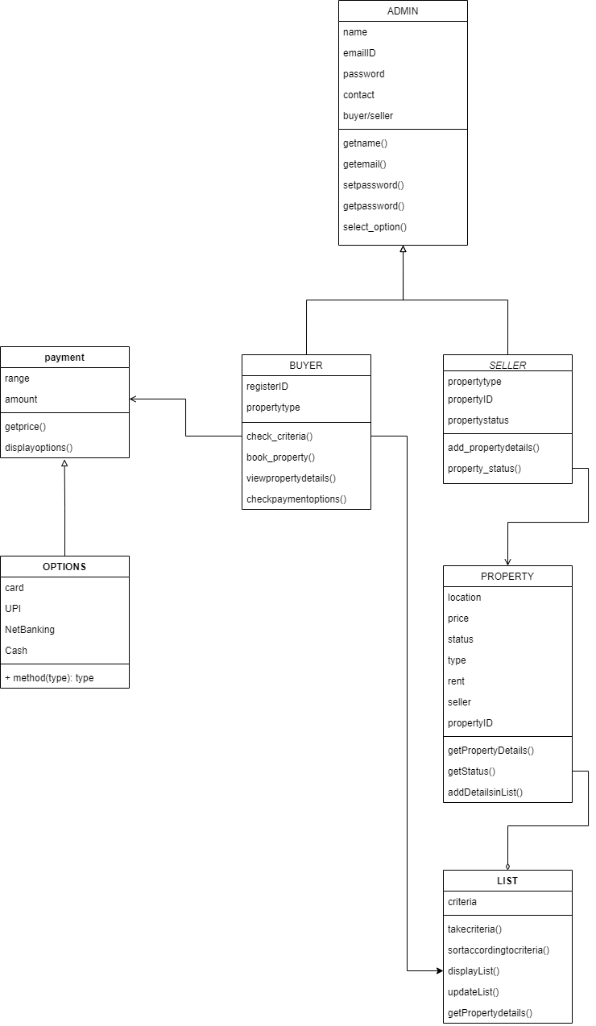

Class Diagram

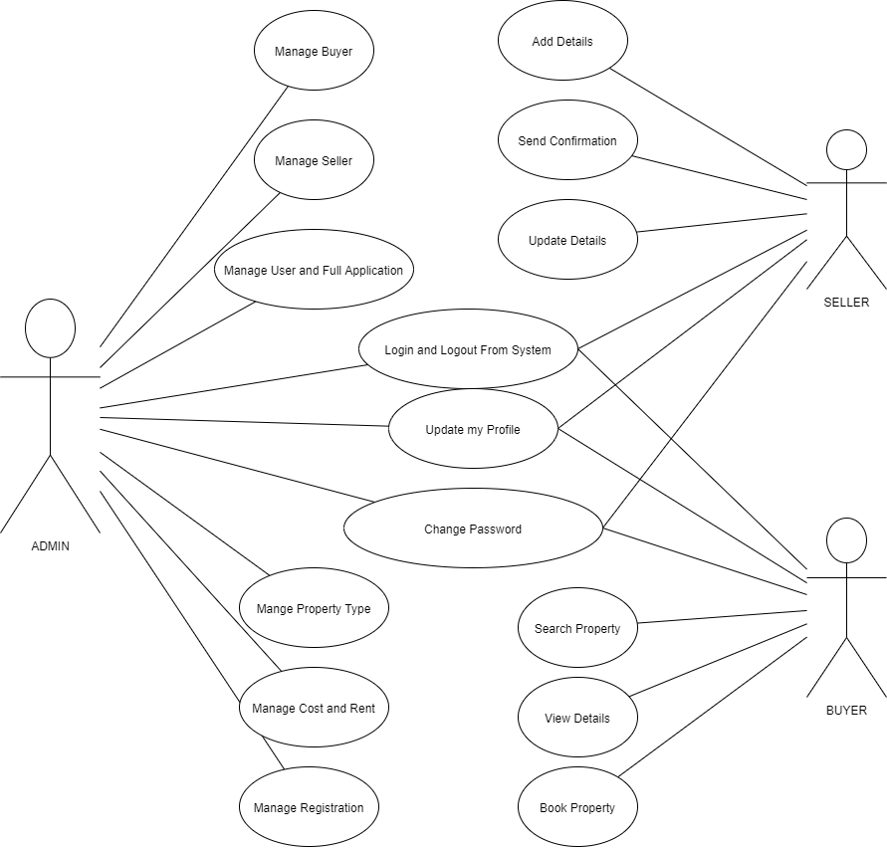

USE CASE DIAGRAM

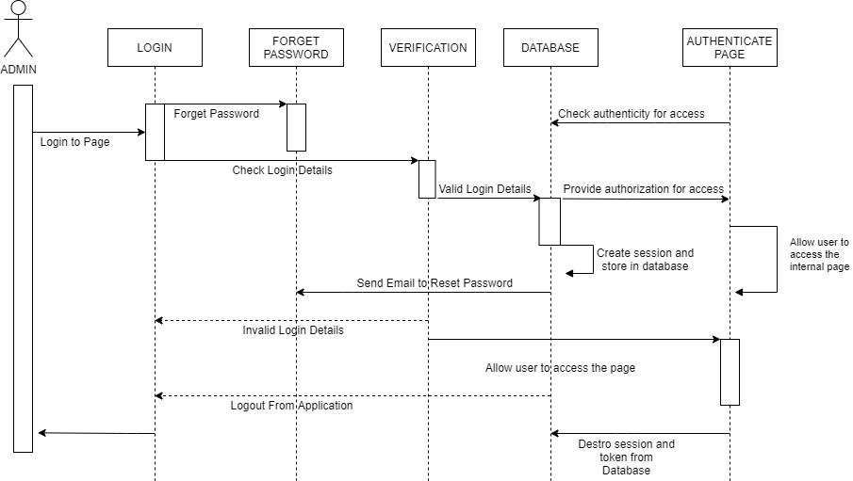

Sequence Diagram

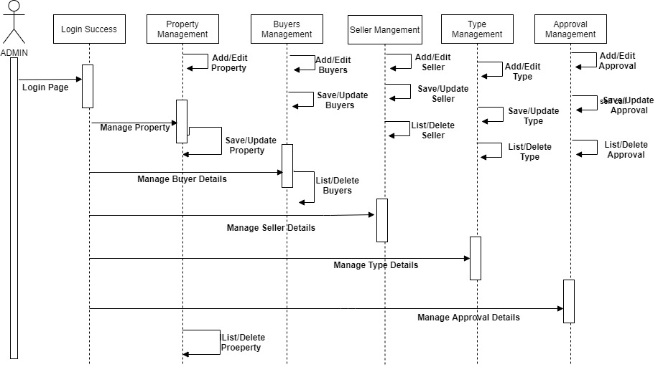

**STATE CHART DIAGRAM**

